AL-NG9-1-1-RFP-16-001 - ATTACHMENT D TECHNICAL SPECIFICATIONS
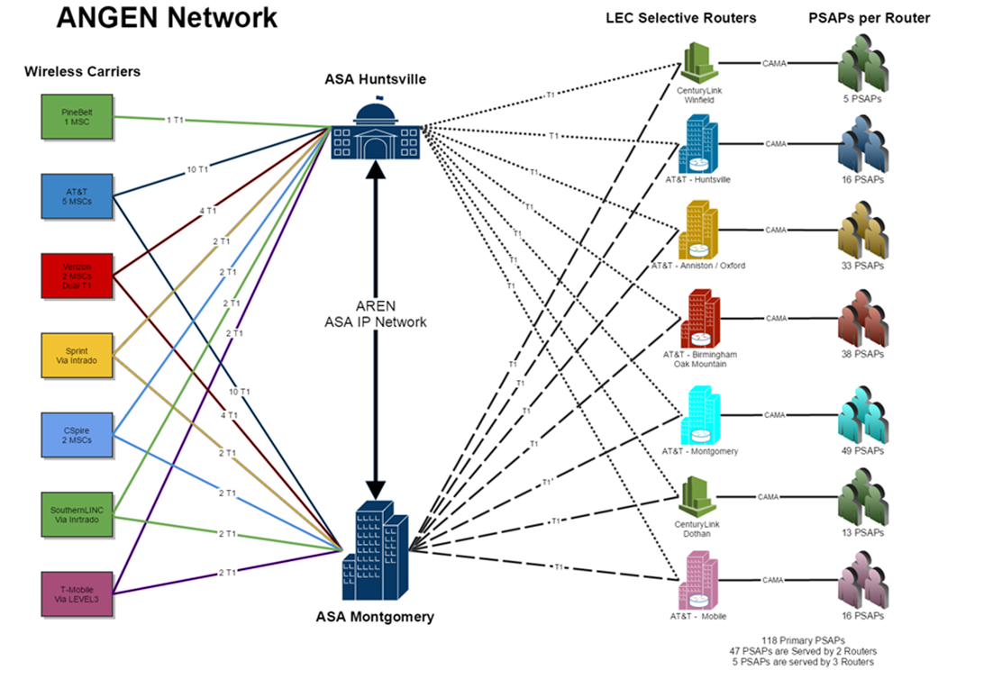

Table of Contents
ATTACHMENT D TECHNICAL SPECIFICATIONS 4
SECTION 1 RESPONSE INSTRUCTIONS 4
1.1 GENERAL RESPONSE INSTRUCTIONS 4
1.2 SCOPE OF PROCUREMENT 5
1.3 STANDARDS 7
1.4 ANGEN BACKGROUND 8
SECTION 2 ANGEN ESINET REQUIREMENTS 16
2.1 ANGEN ESINET DESIGN GOALS AND OBJECTIVES 16
2.2 ANGEN ESINET SERVICES 17
2.3 ANGEN ESINET ARCHITECTURE REQUIREMENTS 18
2.4 ANGEN ESINET FEATURES AND FUNCTIONS 19
2.5 ANGEN NETWORK FAILOVER 26
2.6 ANGEN NETWORK SECURITY 26
SECTION 3 ANGEN SPECIFIC REQUIREMENTS 29
3.1 SYSTEM SERVICE PROVIDER COORDINATION REQUIREMENTS 29
3.2 INTERSTATE INTERCONNECTION REQUIREMENTS 30
3.3 TEXT TO 9-1-1 REQUIREMENTS 30
SECTION 4 ANGEN i3/NG CORE SERVICES REQUIREMENTS 33
4.1 NENA I3 NG CORE FUNCTIONAL REQUIREMENTS 33
4.2 BORDER CONTROL FUNCTION (BCF) 34
4.3 EMERGENCY CALL ROUTING FUNCTION (ECRF) 34
4.4 EMERGENCY SERVICES ROUTING PROXY (ESRP) 36
4.5 LEGACY NETWORK GATEWAY (LNG) 37
4.6 LEGACY PSAP GATEWAY (LPG) 37
4.7 LEGACY SELECTIVE ROUTER GATEWAY (LSRG) 38
4.8 LOCATION VALIDATION FUNCTION (LVF) 38
4.9 LEGACY DATABASE SERVICES 39
4.10 DISASTER RECOVERY / BUSINESS CONTINUITY 40
SECTION 5 SYSTEM REPORTING and i3 LOGGING REQUIREMENTS 41
5.1 REPORTING AND DATA COLLECTION SYSTEM REQUIREMENTS 41
5.2 STATEWIDE STATISTICAL MONITORING 41
5.3 OPERATIONAL REPORTING AND LOGGING 42
SECTION 6 SERVICE/SUPPORT REQUIREMENTS 44
6.1 CUSTOMER SUPPORT SERVICES 44
6.2 HELP DESK 45
6.3 TROUBLE HANDLING AND TICKETING REQUIREMENTS 45
6.4 TRAINING 46
6.5 MONITORING OF APPLICATIONS AND EQUIPMENT 47
6.6 NETWORK OPERATIONS CENTER 47
6.7 ALARM CATEGORIES 48
6.8 SCHEDULED MAINTENANCE 48
SECTION 7 ELECTRICAL, WIRING, AND CABLE REQUIREMENTS 49
7.1 ELECTRICAL 49
7.2 ELECTRICAL INTERFERENCE 49
7.3 WIRING AND CABLING 49
7.4 GROUNDING 50
7.5 TRANSIENT VOLTAGE SURGE SUPPRESSION 50
SECTION 8 PROJECT MANAGEMENT AND PLANNING REQUIREMENTS 51
8.1 IMPLEMENTATION PROJECT PLAN 51
8.2 SYSTEM TEST PLAN 51
8.3 TRANSITION PLAN 52
8.4 SERVICE MANAGEMENT PLAN 53

Figure 1 - Current ANGEN Connectivity Diagram 10
Figure 2 – Current ANGEN Component Re-Use Diagram 11
Figure 3 - Chart of ANGEN Call Volumes by Month 2015 14
Figure 4 – Current ANGEN Call Routing Diagram 15
Figure 5 - ANGEN Conceptual Design Diagram 16
Figure 6 - ANGEN ESInet Goals and Design Considerations 17
Figure 7 - ANGEN Conceptual Design Diagram 29
Figure 8 - ANGEN Conceptual Design Diagram 33

Table 1 - 2015 ANGEN Call Volumes by County 13

ATTACHMENT D TECHNICAL SPECIFICATIONS

AL-NG9-1-1-RFP-16-001

SECTION 1 RESPONSE INSTRUCTIONS

1.1 GENERAL RESPONSE INSTRUCTIONS
Respondents must respond with either COMPLY, NON COMPLY or EXCEPTION to all of the sections and requirements in this RFP.

It is recommended that all detailed responses are located under the section heading and section verbiage to aid in evaluation. Enter your response(s) in line with the sections and requirements at the end of each section. If no clear order is followed; the response may be disqualified.

Respondents that take an EXCEPTION to a particular requirement must provide an alternative to the required feature or function specified. The alternative must describe in detail how it meets the original requirement and must include any other pertinent information that may be necessary to properly consider the alternative being offered (i.e. diagrams, enhanced capability, design efficiency, cost savings, etc.).

The Board recognizes that in some cases Respondents may be able to provide a service or function that is superior to the requirements listed. If the Respondent wishes to present such an alternative, an EXCEPTION should be used to clearly articulate the functionality that Respondents would like to propose as an alternative for evaluation.

The requirements specified in this RFP are identified as MUST haves, SHALL haves, REQUIRED, REQUIRES, or REQUIREMENT(S).

Each proposal will be evaluated according to how well the requirements have been addressed.

Features and functions listed as DESIRABLE are not required. Desirable features and functions add value to a requirement. Respondents are encouraged to provide desirable features and functions where they have an opportunity to maximize the value to the Board while also satisfying the underlying requirement.

Desirable features, functions or elements are described in the RFP as SHOULD, MAY, COULD or DESIRED.

1.2 SCOPE OF PROCUREMENT

1.2.1 PURPOSE
The Alabama 9-1-1 Board (AL9-1-1, the Board) seeks competitive bids from qualified vendors to provide integrated network services for the operation of the ANGEN Network currently serving the PSAPs of Alabama. Alabama is currently served by a wireless 9-1-1 call delivery network known as ANGEN.

The purpose of this procurement is to ensure that at a minimum, the current services provided by the existing ANGEN Network are continued and improved upon as technology, standards, and societal demands evolve.

The AL9-1-1 Board invites qualified vendors with documented expertise and experience to submit proposals to provide wireless and wireline E9-1-1 call delivery, i3 ESInet Network Services, reporting, monitoring, service and support for the operation of the ANGEN Network.

1.2.2 PROJECT OVERVIEW
This procurement will result in the selection of a service provider or a combination of service providers whose proposed solution(s) and services as sought by this RFP will at a minimum, provide the existing level of service as provided by the current ANGEN network to include all existing capabilities, functions, components and ancillary services to all Alabama PSAPs either directly or in collaboration with other systems, services and providers both in Alabama and in adjoining states (MS, TN, FL and GA).

This RFP does not include PSAP CPE, PSAP call taking equipment, furniture, computers or other operational systems required by PSAPs. It is focused only on the services required for the operation of the ANGEN Network and the services it provides to Alabama PSAPs.

The solution(s) and services sought through this RFP may be proposed as an integrated, comprehensive solution, or as a stand-alone component representing a best in class service offering capable of being integrated with other components that will comprise the ANGEN ecosystem.

The Board may, at its discretion, integrate proposed solutions or components of proposed solutions in order to achieve an enterprise-wide, statewide, best in class system that benefits all Alabama PSAPs and best serves the Board in fulfilling its duties under the law.

The Board would prefer an integrated solution with a designated primary vendor contractually responsible for providing the services as specified in this RFP.

The Board may, at its discretion, designate a contractual prime vendor and require contractual relationships, cooperative agreements, interconnection to and interaction with other system service providers or third parties as required or necessary for the operation of ANGEN.

Through this procurement the Board seeks to procure a solution or combination of solutions that:
- Are designed to industry standard including the NENA i3 standard (Section 1.6)
- Provides or supports a foundation for NG9-1-1 and is designed to support or interoperate with core i3 functionality (Section 4)
- Are secure and resilient to cyber-attack, penetration, abuse or misuse (Section 2)
- Provide the ability to alarm, report, monitor, manage and support on a 24/7/365 basis (Section 6)
- Be able to support or integrate with Interim SMS Text-to-9-1-1 solutions that are currently in-place or planned via delivery methods as prescribed by the Board, as per FCC order or by Carrier consent decree (Section 3)
  - Both inbound and outbound via a TCC and/or through the use of direct SIP based MSRP messaging as prescribed in NENA i3
- Provides or Supports Wireless and Wireline E9-1-1 Call Routing and Data Delivery (Section 3)
  - Is capable of the primary receipt, routing and delivery of Wireless 9-1-1 calls from wireless carriers via an ESInet to any PSAP throughout Alabama and neighboring states (MS, TN, GA, FL) or
  - A solution capable of supporting, integrating with and assisting in the delivery of Wireline E9-1-1 Calls to any Alabama PSAP and neighboring states.
  - A solution capable of supporting, integrating with and assisting in the delivery of Wireless E9-1-1 Calls to any Alabama PSAP and neighboring states.
- Provides or supports Increased fault tolerance, reliability, resiliency and disaster recovery across Alabama (Section 2)
- Provides for or supports Enterprise wide call accounting and data collection (Section 5)

1.2.3 SCOPE OF SERVICES
The Board is seeking to procure services from qualified vendors that include the highest degree of resiliency, reliability and redundancy to ensure service availability in keeping with industry standard and best practices.
The services sought by this RFP include:
- ESInet network design, management, and operation services
- NG, i3 core functions and capabilities
- Wireless and Wireline E9-1-1 call routing and reporting services
- Text to 9-1-1 services
- Enterprise/State-wide data collection and reporting services on all ANGEN facilitated transactions
- System and component level monitoring, alarming, diagnostics and reporting services
- Disaster recovery and system restoration services
- 24/7/365 Help desk, trouble ticketing and customer facing support services
- 24/7/365 Network operations center (NOC) monitoring services
- Installation, testing, maintenance and on-site support services
- Project management services for the planning, design, testing, installation and operation of the system or systems

The Board does not favor one technology or platform. This RFP is designed to allow providers to package, represent and demonstrate their services. The Board will evaluate each service on its own merit to determine the best solution(s) for the State of Alabama.
This overview of the Scope of the effort is meant to provide a high level understanding of the objectives. This technical specification provides greater detail of the requirements in the following sections.

1.3 STANDARDS
Respondents shall demonstrate their industry knowledge and describe their commitment to providing standards based solutions and services.
The Board may disqualify or reject non-standard or proprietary systems that may hinder NG9-1-1 implementation, limit interoperability, or that might restrict the State from interconnecting to a regional or national 9-1-1 system in the future.
Throughout the duration of the project, Respondents shall maintain compliance with all standards and ensure that the products, solutions and services provided for ANGEN evolve and adapt as the standards evolve.
In addition to all other standards set forth herein and in addition to all other NENA i3 standards, the system shall comply with the following standards:
- NENA 08-003 v1 Detailed Functional and Interface Specification for the NENA i3 Solution, Stage 3 Version 1
- NENA 08-002 NENA Functional and Interface Standards for Next Generation 9-1-1 Version 1.0 (i3)
- NENA 08-751 NENA i3 Technical Requirements Document
- NENA 04-001 v2 PSAP E9-1-1 PSAP Equipment
- NENA 58-001 NENA IP-Capable PSAP Minimum Operational Requirements Standards
- NENA 58-501 IP PSAP 9-1-1 System Features and Capabilities
- NENA 75-001 Security for Next Generation 9-1-1 Standard (NG-SEC), NENA 75-001 v1, and NENA 04-503 v1
- NENA 75-502, NENA 04-502 v1, NENA 04-503 v1, NENA 08-506 v1, NENA 08-752 v1, NENA 71-502 v1, NENA STA-003
- Applicable Internet Engineering Task Force Standards (IETF), such as IP protocols, IP routing protocols, SIP, RTP, LoST, and the PIDF-LO
- NENA 08-506 Emergency Services IP Network Design for NG9-1-1

While specific standards and documents are referenced in the list above, the Board acknowledges that work on these standards is underway and that many of these standards are in the process of being updated and at the time of RFP distribution may now be referenced by a different number or nomenclature. If there are any discrepancies between the items listed above and a current standard or informational document, the most current version will apply.

Respondents shall describe in detail in the response how they shall meet such standards in their design.

Federal Communications Commission Rules
All equipment must conform to Federal Communications Commission (FCC) Rules Part 15, Class A (commercial, non-residential radiation and conduction limits) for electromagnetic interference (EMI).
Other Industry Standards
Where applicable, all equipment proposed to support or operate ANGEN must comply with applicable industry standards, such as:
- Underwriters Laboratories (UL)
- International Organization of Standards (ISO)
- Open System Interconnection (OSI)
- Institute of Electrical and Electronics Engineers (IEEE)
- American National Standards Institute (ANSI)
- Electronic Industries Alliance (EIA)
- Telecommunications Industry Association (TIA), (including ANSI/EIA/TIA-568 Commercial Building Telecommunications Wiring Standards), etc.

1.3.1 OPEN STANDARDS
Respondents shall propose a system that utilizes an Open Standards methodology.
The proposed system shall be subject to standards that enhance open standards and increase interoperability such as ITU, IEEE 802 at ISO Layer-2, and IP and TCP, as defined by the IETF in the applicable RFCs, at ISO Layer-3 and above.
If proprietary standards or protocols are used within a proposed solution; Respondents shall disclose the proprietary nature and discuss any limitations that may result.

1.4 ANGEN BACKGROUND
The state of Alabama has a long history of leadership in 9-1-1 services, claiming the nation’s first 9-1-1 call in 1968 over a local system in the town of Haleyville soon after AT&T announced the designation of 9-1-1 as a national emergency number.

More than 40 years later, the state’s circuit-switched copper-wire system was struggling to keep up with telecom advances that included wireless mobile phones and Voice over IP.

Work on the present day ANGEN system began in June 2012. Wireless traffic is the current primary focus of the ANGEN system because it accounts for the majority of emergency calls in Alabama, as much as 70 percent in some places.

The ultimate goal of ANGEN is to provide NG9-1-1 services that combine voice, video, text and data on a single emergency communications platform, to let callers use the services they are accustomed to on their smart phones and other devices when making emergency calls, as well as provide additional information to first responders.

ANGEN relies upon and uses the Alabama Supercomputer Authority backbone network (ASA) for interconnection between two aggregation points located in Huntsville AL and Montgomery AL.

All wireless carriers providing service in AL interconnect and aggregate all circuits used for wireless 9-1-1 traffic redundantly to these two aggregation points. This forms the basis for the current level of service for ANGEN.

Current ANGEN Partners include:

Local 9-1-1 Districts – All counties and some cities have 9-1-1 Districts to set policy and manage the local PSAP or PSAPs. County Commissions or City Councils appoint the District Boards, or the elected officials sometimes serve as the 9-1-1 Board.

Alabama 9-1-1 Board – The board is charged with administering the $1.75 collected monthly from each phone account for 9-1-1 expenses. The Alabama 9-1-1 Board administered the grant awarded to the Alabama Department of Homeland Security, which partially funded the implementation of ANGEN.

Bandwidth Inc – current system service provider provides the hardware, software, and support services to route wireless 9-1-1 calls to the proper PSAP using the legacy Selective Routers. There are two core facilities in different parts of the state, either of which can handle the entire State if needed.

Alabama Supercomputer Authority (ASA) – Provisions and manages the physical IP network and the redundant and diverse back-bone network that connects the two core facilities in Huntsville and Montgomery.

Current ANGEN Network Diagram

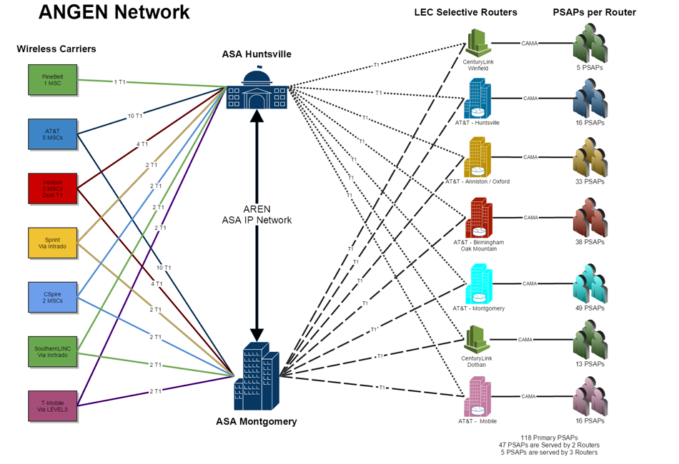
Figure 1 - Current ANGEN Connectivity Diagram
The diagram above represents the logical network connectivity currently employed by the ANGEN system. This diagram is current as of the distribution of this RFP. This diagram will be used and referenced here for the purposes of defining certain requirements and design considerations for any proposed solutions offered by Respondents.

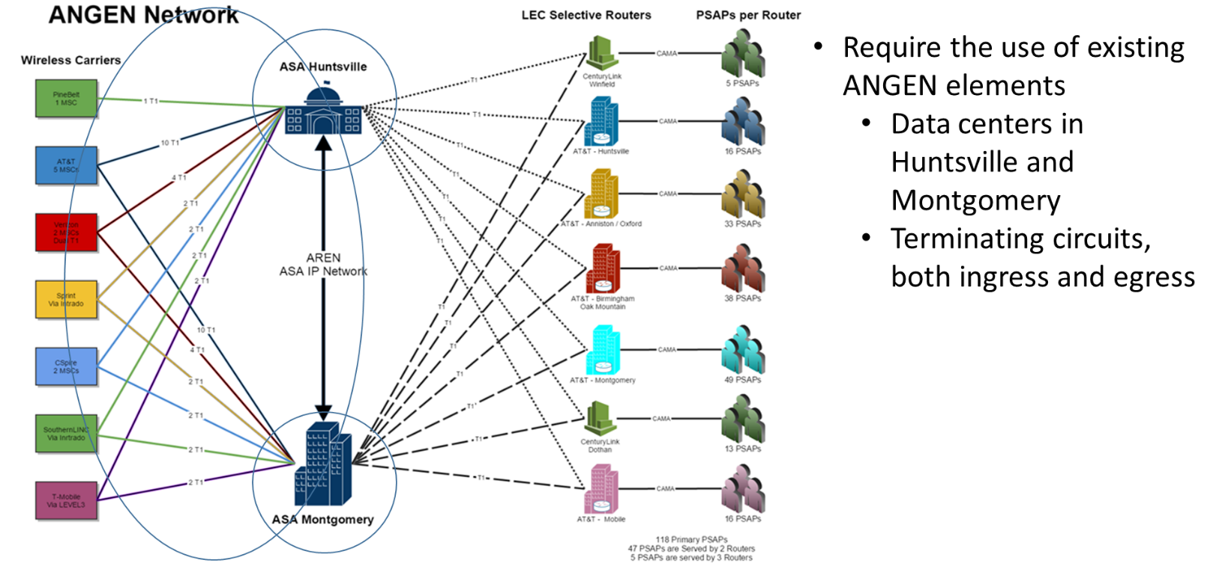
Figure 2 – Current ANGEN Component Re-Use Diagram
The Board’s preference is to reuse and repurpose the existing elements of ANGEN represented in the diagram above. Respondents must take this into consideration in any solution proposed and designed in response to this RFP.

Due to the critical nature of operational specifics regarding the capabilities and operation of ANGEN, additional details and information related to the current ANGEN design, configuration, capabilities, connections and operations will be shared with Respondents deemed qualified after the initial receipt of proposals to this RFP.

ANGEN 2015 Operating Metrics

2015 ANGEN Call Volumes By County
County | 2015 Total | Average Month | % State
Jefferson | 571,830 | 47,653 | 20.9077%
Mobile | 284,576 | 23,715 | 10.4049%
Montgomery | 210,670 | 17,556 | 7.7027%
Madison | 152,949 | 12,746 | 5.5922%
Tuscaloosa | 138,640 | 11,553 | 5.0691%
Baldwin | 77,515 | 6,460 | 2.8342%
Lee | 70,111 | 5,843 | 2.5634%
Shelby | 61,533 | 5,128 | 2.2498%
Houston | 56,803 | 4,734 | 2.0769%
Etowah | 55,720 | 4,643 | 2.0373%
Calhoun | 51,523 | 4,294 | 1.8838%
Russell | 48,684 | 4,057 | 1.7800%
Morgan | 46,305 | 3,859 | 1.6930%
Talladega | 45,321 | 3,777 | 1.6571%
Lauderdale | 41,298 | 3,442 | 1.5100%
Dallas | 41,044 | 3,420 | 1.5007%
Cullman | 34,702 | 2,892 | 1.2688%
Marshall | 33,925 | 2,827 | 1.2404%
St Clair | 33,867 | 2,822 | 1.2383%
Elmore | 32,522 | 2,710 | 1.1891%
Walker | 31,516 | 2,626 | 1.1523%
Limestone | 25,180 | 2,098 | 0.9206%
Colbert | 24,895 | 2,075 | 0.9102%
Escambia | 24,571 | 2,048 | 0.8984%
Chilton | 23,117 | 1,926 | 0.8452%
Blount | 22,896 | 1,908 | 0.8371%
Autauga | 21,362 | 1,780 | 0.7811%
Coffee | 21,178 | 1,765 | 0.7743%
Dale | 20,105 | 1,675 | 0.7351%
Butler | 19,534 | 1,628 | 0.7142%
DeKalb | 19,174 | 1,598 | 0.7011%
Chambers | 18,931 | 1,578 | 0.6922%
Marion | 17,552 | 1,463 | 0.6417%
Covington | 16,703 | 1,392 | 0.6107%
Marengo | 16,251 | 1,354 | 0.5942%
Pike | 15,907 | 1,326 | 0.5816%
Tallapoosa | 15,805 | 1,317 | 0.5779%
Franklin | 15,769 | 1,314 | 0.5766%
Macon | 15,523 | 1,294 | 0.5676%
Sumter | 15,033 | 1,253 | 0.5496%
Pickens | 14,943 | 1,245 | 0.5464%
Jackson | 14,942 | 1,245 | 0.5463%
Monroe | 13,168 | 1,097 | 0.4815%
Lawrence | 12,819 | 1,068 | 0.4687%
Greene | 12,689 | 1,057 | 0.4639%
Clarke | 12,583 | 1,049 | 0.4601%
Hale | 11,516 | 960 | 0.4211%
Barbour | 11,360 | 947 | 0.4154%
Geneva | 10,746 | 896 | 0.3929%
Cherokee | 10,580 | 882 | 0.3868%
Lowndes | 10,263 | 855 | 0.3752%
Perry | 10,199 | 850 | 0.3729%
Winston | 10,084 | 840 | 0.3687%
Conecuh | 9,252 | 771 | 0.3383%
Bibb | 8,457 | 705 | 0.3092%
Cleburne | 7,841 | 653 | 0.2867%
Wilcox | 7,615 | 635 | 0.2784%
Washington | 7,603 | 634 | 0.2780%
Lamar | 6,787 | 566 | 0.2482%
Crenshaw | 6,629 | 552 | 0.2424%
Randolph | 6,609 | 551 | 0.2416%
Choctaw | 6,242 | 520 | 0.2282%
Fayette | 5,648 | 471 | 0.2065%
Henry | 4,910 | 409 | 0.1795%
Bullock | 4,475 | 373 | 0.1636%
Clay | 3,353 | 279 | 0.1226%
Coosa | 3,174 | 265 | 0.1161%
Grand Total | 2,735,027 | 227,919 | 100.0000%
Table 1 - 2015 ANGEN Call Volumes by County
The table above represents the ANGEN operational call volumes by AL county for 2015. These figures represent all Wireless E9-1-1 calls processed in Alabama in 2015 and processed by the ANGEN system. This table can be used for reference in design considerations of any proposed solutions provided in response to this RFP.

Current ANGEN Call Volumes by Month 2015
The chart below depicts actual wireless E9-1-1 call volumes by month of the ANGEN system. The information represented below can be used for estimating system capacities and call volumes and can be used as a basis for developing initial cost estimates.

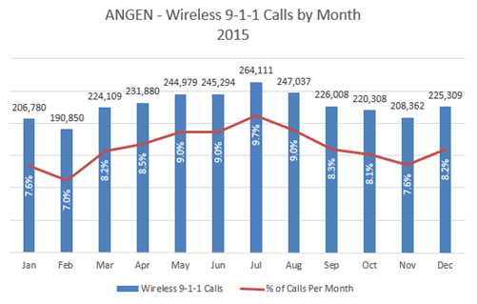
Figure 3 - Chart of ANGEN Call Volumes by Month 2015

Current ANGEN Call Routing Diagram

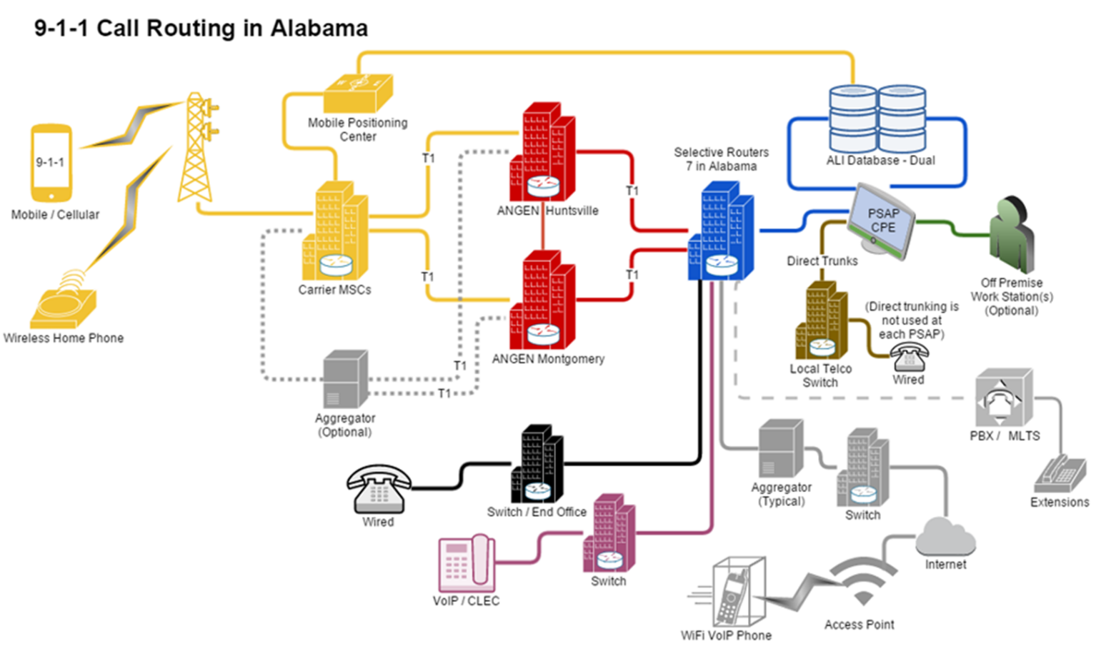
Figure 4 – Current ANGEN Call Routing Diagram
The diagram above provides the logical call flow and routing of the current ANGEN system. Additional details include:
- Each carrier purchases the network to the core facilities and the State's vendor purchases the circuits to the selective routers.
- Emergency Communications Districts (ECDs) purchase the circuits from the selective routers to the PSAP.

SECTION 2 ANGEN ESINET REQUIREMENTS
This section provides the ANGEN ESInet requirements and design considerations for Respondent’s to this RFP.

2.1 ANGEN ESINET DESIGN GOALS AND OBJECTIVES
ANGEN Conceptual Design Diagrams for Reference
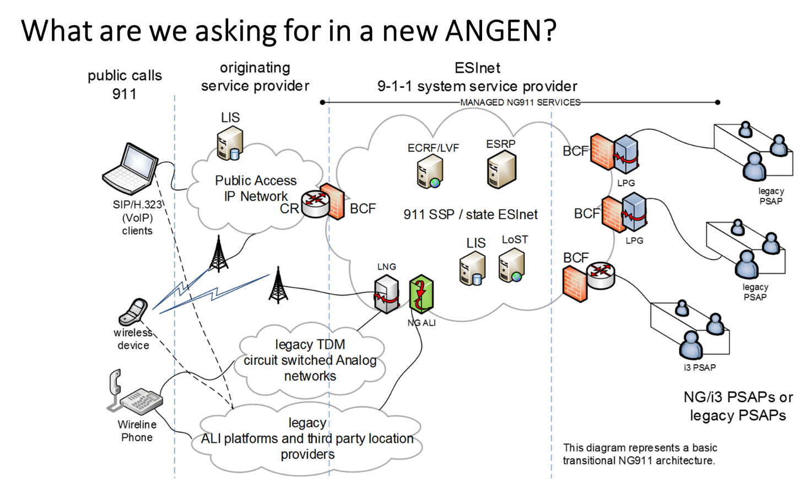
Figure 5 - ANGEN Conceptual Design Diagram
The diagram above represents the conceptual end state of the Future ANGEN system and services as desired by the Board and sought by this RFP. The ESInet will be designed to support and facilitate the operational services provided by the ANGEN system functional elements represented in the diagram above.

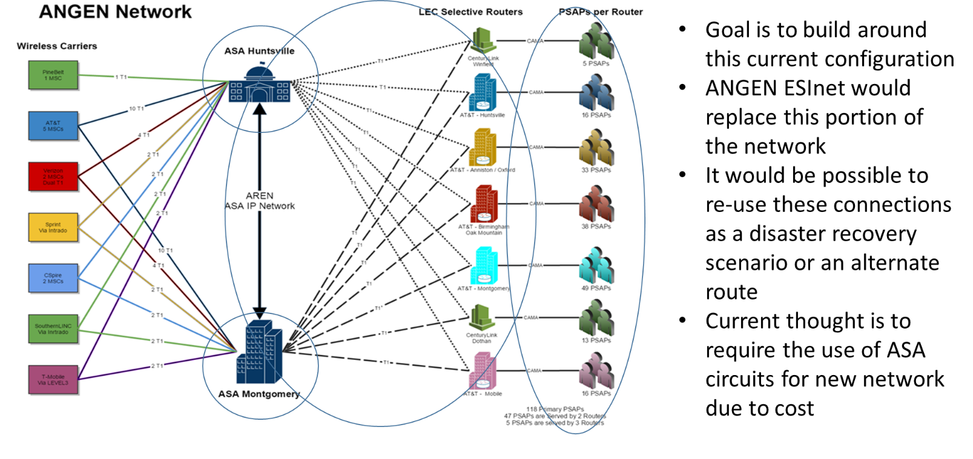
Figure 6 - ANGEN ESInet Goals and Design Considerations

PSAP Information
Alabama is made up of 67 counties with a population of 4,850,000. This population is served by 88 Emergency Communications Districts representing 118 Primary PSAPs. For the purposes of this procurement, the following number of PSAPs are within the scope of this project and anticipated services.
- There are 118 Primary PSAP’s in the state.
- There are 88 ECDs in the state

For the purposes of this procurement, any solutions or services that require provisioning to a PSAP, the number of PSAPs to be considered will be 118 as explained and derived above.

All of the 118 PSAPs are currently operational and fully deployed E9-1-1, Wireless Phase 1 and Phase 2.
Specific address information for each of the 118 Alabama PSAPs covered by this RFP will be made available to qualified respondents as appropriate and necessary for the refinement of costs and designs of proposed solution(s).

2.2 ANGEN ESINET SERVICES
The Board seeks network and operations services from a provider or a combination of providers to implement an Emergency Services IP-network (ESInet) to deliver or support the delivery of voice, text, or other emergency communications related data to the PSAP’s throughout Alabama and in the adjoining states of MS, TN, GA and FL or as may be designated by the Board.
The ESInet(s) will be the foundational technology for keeping Alabama on the forefront of the transition to Next Generation 9-1-1 features, functions and capabilities during the term of the contract and will form the core technology of the ANGEN ecosystem.
Respondents interested in providing ESInet services must design and provide an IP based network solution with the ability to connect and interconnect to other regional, state and potentially national emergency services networks (i.e. FirstNet).
The proposed solution must at a minimum deliver the same functionality of the current ANGEN system as detailed in Section 1 of this specification.
Successful respondents will provide all services necessary for the development, implementation operation, monitoring and maintenance of their proposed ESInet including:
- Design, installation, testing, interconnection and operation of ESInet components required to operate or support the operation of ANGEN
- Maintenance and repair of those elements of the ESInet and interconnections owned, operated, installed or controlled by Respondents as part of their solution
- Completion of as built drawings, sketches and/or schematic materials related to the ESInet
- A data collection and reporting system for all ESInet elements so operational metrics of the ESInet can be monitored, reported and analyzed

2.3 ANGEN ESINET ARCHITECTURE REQUIREMENTS
Any ESInet proposed in response to this RFP must conform to NENA 08-506, Emergency Services IP Network Design for NG9-1-1 (ESIND) and other industry standards as referenced in Section 1 of this specification.
ESInet design requirements include but are not limited to:
- The ESInet shall be designed with as few single points of failure as practical. Diverse network elements and paths, redundant equipment, and other technical and physical means will be used to reduce the potential for total loss of service where a single point of failure is not reasonably avoidable.
- The ESInet shall be designed with a minimum level of bandwidth to support delivery of calls and associated data from originating service providers or other integrated ESInets to the PSAPs.
- The ESInet shall be designed and deployed using a highly reliable and redundant architecture.
- Availability, diversity, redundancy and resiliency shall be the guiding ESInet design principals
- The ESInet design shall support the ability to automatically reroute traffic to alternate routes or systems in order to bypass network outages and system failures.
- The ESInet design shall offer the ability to prioritize critical traffic at multiple levels by importance of applications or users
- The ESInet design shall be scalable and have the ability to scale without adverse effects on performance or costs
- The ESInet shall be designed to support a guaranteed Quality of Service (QoS) level
- The ESInet shall be designed to support the automatic adjustment of traffic priorities in order to meet established QoS levels as defined in NENA 08-003
- The ESInet design shall support the ability to ensure performance through the use of traffic shaping and traffic policing.
- The ESInet shall be designed to operate on a 24x7x365 basis.
- An ESInet design that utilizes the most cost effective and feasible combination of transport technologies available to deliver the bandwidth required.
- The ESInet design shall support the ability to handle legacy 9-1-1 calls and ensure the capability of handling future call types.

2.3.1 ESINET NETWORK DIAGRAM(S)
Respondents shall provide Network Diagrams to support their narrative that accurately displays how their proposed ESInet will be configured and deployed.
The Network Diagrams shall display information about the core ESInet design, the configuration, the interconnections and the access network links so that the diagram can be used as a basis for evaluation and understanding.
ESInet diagrams submitted shall depict, where appropriate, the following aspects of the proposed ESInet solution:
- Network map(s)/Diagram(s)
- Logical topologies
- Physical topologies
- Physical and logical path diversity
- Network ingress and egress points
- Connection types
- Capacities/estimated bandwidth
- Interconnection locations:
- Node locations
- Data Centers
- Aggregation points (both carrier and local access)
- Additional technologies and interfaces as necessary

2.4 ANGEN ESINET FEATURES AND FUNCTIONS
Respondents shall provide a narrative of their proposed ESInet with enough detail to ensure proper evaluation, using diagrams to provide an appropriate level of detail and common language that explains how their proposed ESInet solution is capable of supporting legacy 9-1-1 network options, NG9-1-1, current and evolving standards, and how it will accommodate the integration of other networks operated by other providers that comprise the ANGEN ecosystem.
The narrative will address each of the features or functions listed below (in no particular order):
- Operations
- Security (both physical and logical)
- Availability
- Monitoring
- Alarming
- Maintenance
- Disaster Recovery
- Service restoration
- Outage mitigation
- Core routing
- Interface to Hosted solutions
- Fault zone design methodology

Respondents shall provide a list and a description of all protocols or routing functions that are used in the ESInet infrastructure and ensure that they conform to NENA Detailed Functional and Interface Standards for the NENA i3 Solution NENA STA-010 standards. The proposed ESInet solution must be aligned with NENA 08-003 to ensure that the proposed network does not conflict with open standards specifications.
Respondents shall provide the system narrative immediately following this Section 2.4. Additional requirements and specific technical specifications are detailed in Sections 2.4.1 – 2.4.13

2.4.1 VOLUME AND PERFORMANCE
The ESInet shall be designed to handle, at a minimum, 4,000,000 calls annually, and an estimated 1,000,000 emergency text messages (inbound and outbound) initially.
The wireless traffic high month was 6,617 hours of talk-time.
The ESInet shall be capable of increasing capacity by 10 percent annually over the initial term of the contract.

2.4.2 NETWORK AVAILABILITY & RELIABILITY
The proposed system, including all subsystems, shall be available a minimum of 99.999% of the time when measured on a 24x7x365 basis during a calendar year. Respondents must provide a description of how the availability and reliability will be measured and include a Service Level Agreement (SLA) that is consistent with the recommendations of ESIND and NENA08-003.
Respondents shall explain how the system will achieve this level of availability.

2.4.3 INTERCONNECTION OF OTHER NETWORKS AND SYSTEMS
The proposed solution must be designed to allow for interconnection to other ESInet implementations, PSAP systems (CAD, logging recorders, etc.), criminal justice networks, other 9-1-1 networks or other secure public safety technologies as may be designated by the Board. The proposed solution must ensure “open standards” and describe provisions to collaborate with potential interconnected solutions.
Respondents shall describe the ability for their ESInet solution to interconnect and interoperate with other ESInet implementations, PSAP systems (CAD, logging recorders, etc.), criminal justice networks, other 9-1-1 networks or other secure public safety technologies as may be designated by the Board.
Any IP network approved by the Board to connect to the ESInet shall be required to comply with appropriate ESInet, NENA, and National and Open Standards described in this proposal or as may be current at the time of proposed interconnection.
The ESInet shall be configured in a manner that Board approved edge site Local Area Networks (LANs), such as computer aided dispatch (CAD) systems and/or other Public Safety systems may be connected to utilize the functionality created by the ESInet.
Respondents shall be accountable for ensuring that additional networks meet the minimum qualifications for interconnection presented in this specification and that security of ANGEN is maintained through collaboration with each potential network provider.

2.4.4 QUALITY OF SERVICE FEATURES
Any proposed ESInet shall have quality of service (QoS) features suitable for the real-time transport of VoIP traffic requesting emergency services (as defined in NENA 08-003).
Respondents shall describe their method of managing the QoS features defined below and offer an explanation of how their proposed ESInet will perform to these capabilities
The following ESInet performance requirements are taken directly from NENA 08-506 ESIND:
- Packet Latency (50 ms)
  - Packet Latency shall average a round trip time of fifty (50) milliseconds.
- Packet Loss (5%)
  - Respondents shall design the ESInet without oversubscription and keep the packet loss budget under 5%.
- Jitter (20 ms)
  - Jitter shall not exceed twenty (20) milliseconds.

Respondents shall provide an explanation of the proposed solutions QoS capability that minimizes congestion, mitigates errors and ensures the delivery of Real-Time Transport Protocol (RTP) packets across the ESInet.

2.4.5 TRAFFIC PRIORITIZATION NARRATIVE
Respondents shall describe how their proposed solution manages the prioritization of traffic across the ESInet, how QoS is implemented and describe the interoperability of the IP routing mechanisms.

2.4.6 SCALABILITY
The Board seeks a solution that will accommodate bandwidth changes, additional sites to be added or sites removed, and to interconnect to other regional or statewide ESInets without downtime or substantial increase in operating costs.
Respondents shall describe how their proposed ESInet design permits scalability.

2.4.7 REDUNDANCY AND SURVIVABILITY
The ESInet shall be configured to survive natural or man-made disasters at every core site (Central Office, Point of Presence, Data Center or other central switching location) and shall provide a description of survivable capabilities at all edge sites including PSAPs
Additional requirements for the reliability design of the ESInet shall be guided by the FCC Report and Order FCC 13-158 – Improving 911 Reliability and Reliability and Continuity of Communications Networks, Including Broadband Technologies.
Where available, the ESInet network core solution and redundantly connected sites shall include physically diverse routes and physically diverse building entrances.
Respondents shall provide a detailed description of all single points of failure or specific locations that lack diversity and/or redundancy present within their proposed solution. This includes locations within the proposed ESInet where redundant components, network resources and physical connections DO NOT exist.
Respondents shall explain in detail the redundancy and survivability measures proposed for the ESInet and the core network components.

2.4.8 BANDWIDTH
Respondents shall identify the minimum bandwidth required to handle all anticipated voice and data traffic of the system for the next five (5) years.
At a minimum Respondents shall base their bandwidth estimates on the delivery of all calls and associated data to the PSAP.
In addition, the bandwidth should include requirements for a fully functioning network with all redundant connections in service.

2.4.8.1 PSAP BANDWIDTH
Respondents shall provide a solution that can deliver adequate bandwidth to each PSAP for 9-1-1 voice calls, text to 9-1-1, data communications, and a sufficient surge factor. The growth factor used must conform to the current ANGEN model.
The minimum access portion of the network from the ESInet to the PSAP shall be 10 Megabits per second (Mbps).
Respondents shall continually monitor the bandwidth for the duration of the contract and dynamically increase the bandwidth when appropriate. The selected vendor will be required to supply a SLA consistent with the existing ANGEN solution. A description or sample of the SLA must be included in the response.

2.4.8.2 BANDWIDTH EXPANSION
The ESInet must be capable of expanding as needed throughout the duration of the contract period.

2.4.8.3 BANDWIDTH SHARING
Respondents shall describe how their QoS scheme ensures that separate RTP sessions are not sharing bandwidth.
Since the ESInet may be used for additional services, respondents must provide a description of how bandwidth is prioritized and separated from normal IP traffic.

2.4.8.4 LOSS OF BANDWIDTH
Respondents shall configure the dynamic routing protocol to prevent serious loss of bandwidth, denial of service due to routing table updates or other behavior while providing automatic rerouting as quickly as is reasonably possible.

2.4.9 IP ROUTING
The Board requests that Respondents propose the most efficient and effective IP routing solution that meets the intent of this RFP.
As the transition from IP version 4 (IPv4) and IP version 6 (IPv6) is on-going, the proposed IP network infrastructure shall be configured to support and route both IPv4 and transition into IPv6.
Respondents shall describe how their ESInet configuration meets an ability to associate IPv4 and IPv6 in a seamless routing configuration.
Respondents must also describe how a combined IPv4 and IPv6 platform will be managed and monitored to avoid potential errors.

2.4.9.1 INTERNET PROTOCOL PACKET DELIVERY
Respondents shall ensure that the IP routing protocol used in the ESInet provides delivery of IP packets from end to end. All IP information from one IP device to another IP device within the network must be guaranteed.

2.4.9.2 IP ROUTING PROBLEM RESOLUTION
Respondents shall describe how their proposed solution will interoperate with other operators of interconnected networks and will cooperate with those providers to resolve IP routing problems.
The selected vendor will be responsible for ensuring that discrepancies or deviations from standards within the respondent’s network are documented and corrective action taken to overcome conflicts with other operators.

2.4.9.3 AUTOMATIC INTERNET PROTOCOL REROUTING
Respondents shall describe how their proposed solution minimizes the impact of routing errors within the network by automatically rerouting past failures or interruptions.

2.4.9.4 BACK TO BACK USER AGENT USAGE
Respondents must provide the ability to cross ESInet boundaries to ensure no limitations or dropping of packets. If SIP or RTP traffic needs to cross boundaries the traffic shall be handled by a back to back user agent (B2BUA); a type of session Boarder controller (SBC).
Respondents shall describe where B2BUAs are located within their solution and document the use of B2BUAs in their ESInet. Respondents must include an explanation of how the seamless delivery of traffic can be maintained using SIP and RTP between IPv6 and IPv4 networks.

2.4.9.5 SUBNET NUMBER ASSIGNMENTS
The Board may allow the integration of other networks with the ESInet. To avoid potential conflicts for address space, Respondents shall document and provide a report of all subnet address assignments to the Board prior to implementation of the ESInet.

2.4.9.6 NETWORK STATIC ADDRESSING
Respondents shall ensure that static IP address routing is configured at all core network interfaces to avoid IP configuration errors.

2.4.9.7 “LOOPBACK” INTERFACE
Respondents shall define an interface to allow for loopback testing within the ESInet. The loopback interface shall be installed at each network element to provide administration functions.

2.4.10 DIVERSE NETWORK ENTRIES
The Board requires an ESInet design that incorporates diverse network entries to connection points and PSAPs. The Board recognizes that in several cases there may not be physically diverse entrances into PSAPs.
Where diverse entries are not possible; Respondents shall describe their methodology to implement the most diverse solution possible.
Respondents shall describe their methodology for providing redundancy through the use of diverse network entries where possible.

2.4.11 NETWORK DEMARCATION POINT
Since the ESInet may be interconnected to other ESInets or facilities, Respondents shall establish demarcation points and the physical connection requirements for other operators to connect to the designated demarcation point.
In addition, demarcation between the Access Network facilities that connect an edge site, such as a PSAP site, to the Core Network, meet the Core Network at a point of interconnection (POI).
Respondents shall explain their preferred methodology for establishing network demarcation points.

2.4.12 ACCESS NETWORK - EDGE SITE INTERFACE
The edge or PSAP sites should interface via 100 Megabit per second (Mbps) or faster port speed connection.
This interface to the local LAN is not considered a part of the NG9-1-1 network but should be considered as an element of the ESInet infrastructure.
Respondents shall describe the local area network (LAN) interface at each of the edge sites.

2.4.13 TIME SERVERS
A time server to synchronize all proposed network resources must be included in the proposed solution.

The time server must be connected to redundant time sources located within the ESInet capable of providing accuracy to 20.0 milliseconds (ms) of true time.

Respondents shall include a system for establishing network time protocol for the network in their proposal.

2.5 ANGEN NETWORK FAILOVER
The proposed solution must contain a network failover function that is capable of recognizing faults and automatically taking measures to avoid the fault. At a minimum the network shall provide for instant switch from failed or degraded components, systems, and networks.
The failover system shall conform to industry standards and shall comply with the other recommended standards presented in this RFP and must embrace open standards to maximize the fail over ability of all components.
Respondents shall describe in detail their methodology both operationally and technically for implementing automated network failover as a component of their proposed ESInet.

2.6 ANGEN NETWORK SECURITY
Respondents shall propose a solution that meets a minimum level of security as defined by the national standards.
The Board requires that proposed solutions comply with the Federal Bureau of Investigation (FBI) Criminal Justice Information Services (CJIS) Security policies and practices.
They may be found at http://www.fbi.gov/about-us/cjis/cjis-security-policy-resource-center/view.
Respondents shall propose how their solution meets these security measures and how they comply with future changes to security measures to ensure that:
- Network operations are not disrupted due to a security breach
- Unauthorized individuals cannot access the network
- Least access policy is applied
- Data theft does not occur
- Monthly assessments of vulnerabilities and frequent scans for malicious activity occur
- Security incidents are documented, risks identified, responded to and mitigated
- Management of security changes are documented
- Security documentation is maintained to aid in forensic audits as necessary
- Security data is maintained as recovered and not modified or deleted
- Intrusion protection and Intrusion detection is implemented throughout the network to eliminate breach of security
- Protection from identify theft occurs

Respondents shall include physical and logical security precautions in their proposed solution that meet the minimum criteria outlined above. This includes providing a description of any security based appliances necessary to meet the objectives including:
- Firewalls
- Access Control Lists
- Switches
- Routers
- Intrusion Protection devices
- Intrusion Detection devices
- Specialized Cabling
Respondents shall describe in detail how the proposed network is configured to withstand these attacks and protect the integrity of the entire 9-1-1 system.

2.6.1 INTRUSION PREVENTION AND DETECTION
Respondents shall describe how their proposed intrusion prevention and detection capabilities provide alerting, logging and reporting of security threats by intruders to the network. In addition, the ability to document and log intrusions must be discussed within the response.

2.6.2 ENCRYPTION
Respondents must include the advanced encryption standard (AES) on their proposed solution where appropriate.

2.6.3 NETWORK SECURITY STANDARDS
Respondents shall describe how their network security solution complies with the following Standards:
- NENA Security for Next-Generation 9-1-1 Standard (NG-SEC, document 75-001 dated February 6, 2010)
- Next Generation 9-1-1 Security (NG-SEC)Audit Checklist NENA 75-502 V1
- NENA i3 Technical Requirements Document 08-751
- NENA Detailed Functional and Interface Standards for NENA (i3) Solution Stage 3 08-003
- FBI Criminal Justice Information Services (CJIS) Security Policies
- http://www.fbi.gov/about-us/cjis/cjis-security-policy-resource-center/view

2.6.4 REMOTE ACCESS AND NETWORK SECURITY AND FIREWALLS
Respondents shall specify a firewall solution within its network that provides security and protection to the system. All such interfaces connected shall be in accordance with mandated security requirements.
a. Secure remote access shall be strictly controlled. Control will be enforced via remote access authentication using security tokens that provide one-time password authentication or public/private keys with strong pass-phrases.
b. Remote Access control will be enforced via network and system level auditing.

SECTION 3 ANGEN SPECIFIC REQUIREMENTS

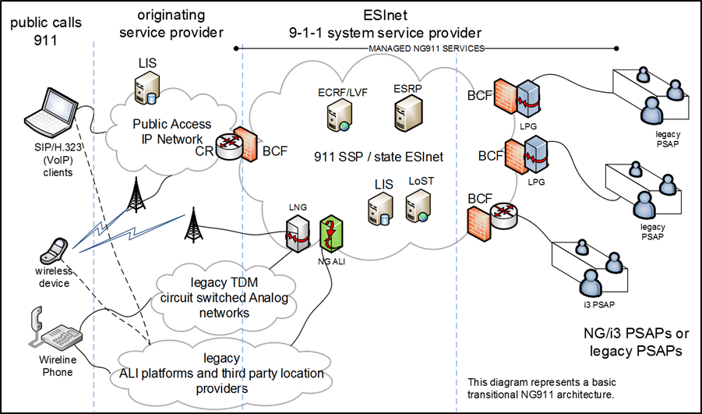
Figure 7 - ANGEN Conceptual Design Diagram

3.1 SYSTEM SERVICE PROVIDER COORDINATION REQUIREMENTS
Successful Respondents will be required to coordinate with other service providers as necessary to operate a seamless solution in support of the operation of ANGEN.

Respondents will need to enter into Interconnection agreements which legally allow the connectivity and interconnection with other networks as well as other service providers throughout Alabama.

This includes but is not limited to LECs, CLECs, ILEC and all Wireless Carriers providing service in Alabama.

Respondents shall provide the Board with example agreements, relationships, licenses or other documents demonstrating Respondents legal ability to enter into such agreements.

Examples of interconnection and cooperative agreements with third parties include but are not limited to:

- pANI (psuedo ANI) and IP provider ALI records integration
- third party providers (TCS and Intrado) E2+ interfaces
- Inter-company ALI server connections (to AT&T, CBT)

3.2 INTERSTATE INTERCONNECTION REQUIREMENTS

Respondents must be capable of interconnecting with other SSPs in states other than Alabama.
States that will need to be interconnected to ANGEN include:
- Florida
- Georgia
- Mississippi
- Tennessee

Respondents shall provide the Board with example agreements, relationships, licenses or other documents demonstrating Respondents legal ability to enter into such agreements in other states.

Respondents must provide an explanation of how these interstate and intrastate capabilities will be achieved.

3.3 TEXT TO 9-1-1 REQUIREMENTS
The intent of this section is to specify a Text solution that is in compliance with the Alliance for Telecommunications Industry Solutions (ATIS) / Telecommunication Industry Association (TIA) J-STD-110, Joint ATIS/TIA Native SMS to 9-1-1 Requirements & Architecture Specification A J-STD-110 Standard.

The Board is looking for Respondents to provide a hosted solution for the processing of text-to-9-1-1 messages on Respondent’s proposed ESInet.

The Board is seeking a text to 9-1-1 emergency telecommunications system that shall possess the highest degree of resiliency, reliability, redundancy, and service availability and conforms to current and evolving industry standard.

The system shall support the delivery of 9-1-1 text calls to all participating PSAPs located throughout Alabama.

Functionally the Board’s desire is to have emergency text messages (text-to-9-1-1) from all wireless carriers aggregated from Respondents’ proposed solution and forwarded to the appropriate PSAP. A TCC function for all of Alabama.

Conceptually the solution will allow a subscriber to a wireless service in the U.S. to send an emergency text to 9-1-1 while in the confines of the State of Alabama and that emergency text will be sent to the appropriate PSAP for answering and processing.

Respondents proposed solution(s) shall aggregate incoming Short Message Service (SMS) text messages from the public through one interface to all Text Control Centers (TCCs) provided by wireless carriers/vendors and distribute the text message to the appropriate Public Safety Answering Point (PSAP) in the format required by that PSAP (web browser, TTY, Direct IP interface).

Respondents proposed solution(s) shall minimize interconnection points between Respondents proposed solution and the PSAP by providing a single content distribution node from the aggregator solution to the PSAP interface.

Such an interface node shall be compatible with all NENA i3 CPE, TTY, and Web-based text displays.

Respondents proposed solution(s) shall only require that a person requiring emergency assistance enter the short code ‘9 1 1’ in their wireless device in order to have an emergency text message sent to the PSAP.

The use of any other short code to send emergency text messages is not required nor shall there be any need for a public person to register their device in order to text 9-1-1 within the defined jurisdiction.

Respondents proposed solution(s), through a distribution method, shall allow messages to be transferred between PSAPs (primary and secondary) that use a web-based browser or NENA i3 CPE interfaces.

Respondents proposed solution(s) shall provide through the distribution method the ability to provide TTY transfer of SMS texts between TTY PSAPs on the same selective router.

Respondents proposed solution(s) should provide an Aggregator function that:
- Will aggregate text-to-9-1-1 messages from multiple TCCs into a single message stream for distribution to the PSAPs
- Supports any ATIS compliant text-enabled CPE interface
- Supports transfer of text sessions between different interfaces

Respondents proposed solution(s) should provide a Distributor function that:
- Receives text-to-9-1-1 messages from the Aggregator and uses the ESRP/ECRF to route the message to the destination PSAP for the PSAPs served by the Distribution server.
- The Distributor includes:
  - TTY Interface – to handle conversion of a text message to a TTY stream for interfacing to a selective router through an Emergency Services Gateway (ESGW)
  - Web Portal – contains a portal for the web-based Respondents solution for use by the call taker
  - SIP/MSRP Interface – interface between the Aggregator and the NENA i3 ESInets or MSRP CPE at the PSAP.

3.3.1 DATA COLLECTION AND REPORTING
The proposed solution shall supply call detail record (CDR) or an equivalent for all text messages. The solution shall provide QoS information, per NENA i3 standards, for each text ‘call’ to ensure that SLAs are being met.

Quality of service information should be accessible through Respondents’ maintenance function.

Respondents shall provide diagrams for their proposed solution showing:
- System connectivity
- System NG9-1-1 functionality including connectivity to network
- Intelligent workstation equipment

3.3.2 PSAP GRAPHICAL USER INTERFACE AND TEXT STATUS WINDOWS (BROWSER METHOD)
Respondents shall include a user interface provided for a web browser that allows a supervisor the ability to modify the system sounds and button icons.

The User interface proposed by Respondents solution must utilize Windows Graphical User Interface (GUI) interfaces using drop-down boxes, check boxes, text boxes, radio buttons. Etc. to facilitate user friendly data entry and editing.

The Intelligent Workstation shall present the text-call-taker, at a minimum, with the status of the following categories:
- Number of Active Text-to-9-1-1 Calls
- Number of Text-to-9-1-1 Calls on Hold
- Number of Text-to-9-1-1 Calls ‘Ringing’
- Number of Active Text-to-9-1-1 Call takers.

SECTION 4 ANGEN i3/NG CORE SERVICES REQUIREMENTS

4.1 NENA I3 NG CORE FUNCTIONAL REQUIREMENTS

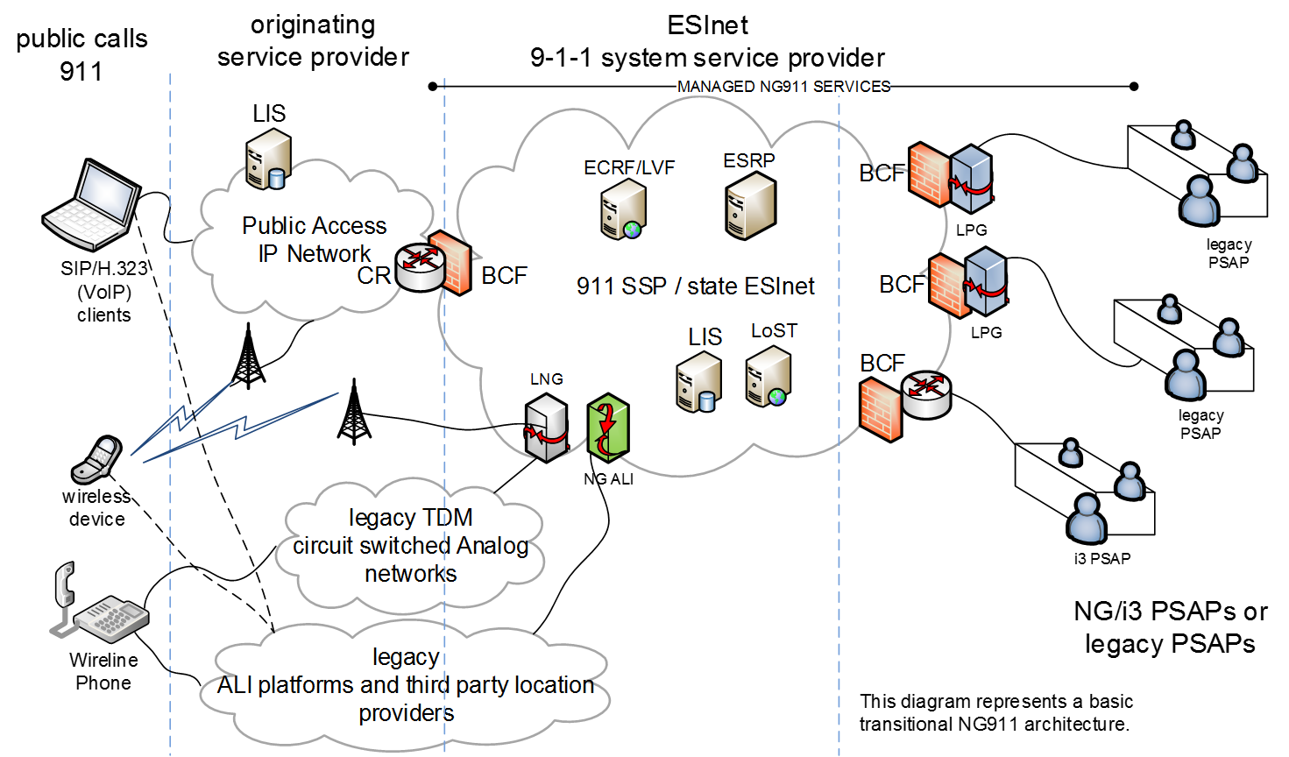
Figure 8 - ANGEN Conceptual Design Diagram
The proposed system shall be designed to meet and expand the current capabilities of the ANGEN system and be scalable and adaptable to accept new payloads (such as Text, Pictures and Video) that may be directed by the Board for deployment during the term of the contract.

ANGEN is currently configured as a wireless carrier aggregation point, which is interconnected to every S/R in Alabama, which then serve and deliver wireless 9-1-1 calls to the PSAPs in AL.

The proposed system is required to provide or accommodate NG9-1-1 core functional elements as well as legacy transitional elements for the continued and future operation of ANGEN.

Those NG9-1-1 core functional and legacy transitional elements include:
- Border control function (BCF)
- Emergency call routing function (ECRF)
- Emergency services routing proxy (ESRP)
- Legacy network gateway (LNG)
- Legacy PSAP gateway (LPG)
- Legacy Selective Router Gateway (LSRG)
- Location Validation Function (LVF)
- Policy routing function (PRF)

Respondents shall explain where these functional components are physically located in their proposed solution and describe how they will operate.

It is recognized that all of the functions may not be required at this time and that some may only be added after transition or at some future point as technologies or standards evolve.

Suggested components that are not used or are not needed in the Respondents proposed solution must be clearly noted as an exception; and an explanation must be given for eliminating the particular component to perform the ANGEN capability.

4.2 BORDER CONTROL FUNCTION (BCF)
Per the NENA i3 NG9-1-1 specification, the network must be configured with a Border Control Function (BCF) at all ingress and egress points.

The BCF shall support a variety of direct IP interconnection arrangements between the ESInet and external IP networks depending on the level of mutual trust that exists between the respective networks.

It is strongly recommended that BCF’s are located at a minimum of two geographically diverse points of interconnection (POI), and support 99.999% availability interconnections to external networks.

Respondents shall explain the features and capabilities of their proposed BCF, along with a brief explanation of how high availability will be achieved.

4.3 EMERGENCY CALL ROUTING FUNCTION (ECRF)
Respondents shall include an emergency call routing function (ECRF) in their proposed solution that utilizes geographic location information to route emergency calls to the appropriate PSAP.

The ECRF shall be designed according to NENA08-003 standards and be implemented using diverse, reliable and secure IP connections.

Respondents shall supply an ECRF function that meets a minimum of 99.999% availability

Respondents providing an ECRF must ensure that it is accessible from outside the ESInet and that the ECRF permits querying by an IP client/endpoint, a Legacy Network Gateway (LNG), an Emergency Services Routing Proxy (ESRP) in a next generation Emergency Services network, or by some combination of these functions.

An ECRF accessible inside an ESInet must permit querying from any entity inside the ESInet. ECRFs provided by other entities may have their own policies on who may query them.

An origination network may use an ECRF, or a similar function within its own network, to determine an appropriate route, equivalent to what would be determined by the authoritative ECRF, to the correct ESInet for the emergency call. Respondents shall describe the functionality of such an ECRF equivalent and document where this functional element resides within their proposed solution.

The ECRF shall support a routing query interface that can be used by an endpoint, ESRP, or PSAP to request location-based routing information from the ECRF. Additionally, it must support both iterative and recursive queries to external ECRF sources.

The ECRF must interface with the Location to Service Translation (LoST) protocol (RFC5222) and support LoST queries via the ESRP, PSAP customer premise equipment (CPE), or any other permitted IP host.

The proposed ECRF must allow for rate limiting queries from sources other than the proposed ESRP(s), and provide logging of all connections, connection attempts, and LoST transactions.

The ECRF must be designed and implemented to support the ability for GIS data management functions to ensure accurate location data is maintained.

The ECRF must support:
- Location error correction.
- Routing of calls based on geographical coordinates and civic addresses.
- Utilize common GIS boundaries (to include but not limited to Municipal, Police, Fire, EMS).
- Permit LoST association with each layer.
- Comply with NENA 02-010 and NENA 02-014.
- Must support dynamic updates to GIS without disruption of the ECRF.
- Validation of GIS updates before they are applied.

GIS is handled locally throughout the State of Alabama. Respondents shall define their method for collecting local PSAP related GIS information and establishing the ECRF.

Respondents shall explain where the ECRF will be located and how it will operate within their proposed solution.

Respondents shall describe how the proposed ECRF and its capabilities, features, functions and protocols provides high reliability routing for all 9-1-1 call types.

Respondents shall describe the interface to the system that provides the ability to upload location information once the Extensible Markup Language (XML) is published and approved for general use, as determined by the Board.

4.4 EMERGENCY SERVICES ROUTING PROXY (ESRP)
The proposed solution must include an emergency service routing proxy for call delivery to the appropriate PSAP based upon location and routing rules.

Respondents shall explain where the ESRP will be located and how it will operate within their proposed solution.

This includes Carrier to ESRP, ESRP to ERSP and ESRP to call-taker routing.

Respondents shall configure the ESRP according to NENA 08-003 specifications and describe the ability of the ESRP to route SIP messages to a call taker.

Respondents shall explain how the ESRP interfaces to the ECRF and to the PRF to ensure that routing instructions, routing policies and possible event notifications that alter call routing scenarios are acknowledged.

Per NENA 08-003 for typical 9-1-1 calls received by an ESRP it;
- Evaluates a policy “rule set” for the queue the call arrives on
- Queries the location-based routing function (ECRF) with the location included with the call to determine the "normal" next hop (smaller political or network subdivision, PSAP or call taker group) URI.
- Evaluate a policy rule set for that URI using other inputs available to it such as headers in the SIP message, time of day, PSAP state, etc.

The result of the policy rule evaluation is a Uniform Resource Identifier (URI). The ESRP forwards the call to the URI.

The ESRP shall support SIP SUBSCRIBE/NOTIFY in order to understand the status of both upstream and downstream elements.

Respondents shall describe their proposed ESRP solution.

4.4.1 POLICY ROUTING FUNCTION (PRF)
The Policy Routing Function (PRF) is the primary routing component of the ESRP. The ESRP uses defined routing policies within the ESInet and the NENA i3 network to deliver calls to the call-takers.

The PRF function requires the ability of the ESRP to assist in dynamically routing and re-routing calls based upon other rules beyond normal operation.

Respondents shall describe how they will operate the PRF functionality and explain how they will implement a proxy that is customizable based upon rules set by threshold or by manual intervention.

Additionally, Respondents shall describe what user interface will be used to modify policy rules and what i3 functions can affect policy changes for call routing.

4.5 LEGACY NETWORK GATEWAY (LNG)
The LNG logically resides between the originating network and the ESInet and allows i3 enabled PSAPs to receive emergency calls from legacy originating networks.

Calls originating in legacy wireline or wireless networks must undergo signaling interworking to convert the incoming Multi-Frequency (MF) or Signaling System Number 7 (SS7) signaling to the IP-based signaling supported by the ESInet.

Thus, the LNG supports a physical SS7 or MF interface on the side of the originating network, and an IP interface which produces SIP signaling towards the ESInet, and must provide the protocol interworking functionality from the SS7 or MF signaling that it receives from the legacy originating network to the SIP signaling used in the ESInet.

The LNG shall be implemented for routing emergency calls to the appropriate ESRP in the ESInet.

To support this routing, the LNG must apply specific interwork functionality to legacy emergency calls that will allow the information provided in the call setup signaling by the wireline switch or MSC (e.g., calling number/ANI, ESRK, cell site/sector represented by an ESRD) to be used as input to the retrieval of location information from an associated location server/database.

The LNG shall use this location information to query an ECRF and obtain routing information in the form of a URI.

The LNG must then forward the call/session request to an ESRP in the ESInet, using the URI provided by the ECRF, and include callback and location information in the outgoing signaling.

While in operation LNG shall be capable of appending supplemental and supportive call information such as location and callback number to the call prior to the ESInet.

The LNG shall also be capable of supporting SIP SUBSCRIBE/NOTIFY in order to understand any downstream elements status and then implement policy routing should a nominal route for a call not be available.

Respondents shall describe how their proposed solution permits a legacy network gateway (LNG) function to integrate the legacy network with the ANGEN core.

4.6 LEGACY PSAP GATEWAY (LPG)
A legacy PSAP gateway (LPG) is used to provide seamless connection to PSAP’s that have not upgraded to NG9-1-1 PSAP operations.

The Legacy PSAP Gateway is a signaling and media interconnection point between an ESInet and a legacy PSAP.

It plays a role in the delivery of emergency calls that traverse an i3 ESInet to get to a legacy PSAP, as well as in the transfer and alternate routing of emergency calls between legacy PSAPs and i3 PSAPs. The LPG shall support the LoST protocol in order to provide selective transfer information (minimally police, fire and EMS) to a legacy PSAP based on the routing polygons provided by the local ECRF.

The Legacy PSAP Gateway supports an IP (i.e., SIP) interface towards the ESInet on one side, and a traditional MF or Enhanced MF interface (comparable to the interface between a traditional Selective Router and a legacy PSAP) on the other.

The Legacy PSAP Gateway also includes an ALI interface (as defined in NENA 04-001 or NENA 04-005) which can accept an ALI query from the legacy PSAP.

The LPG must then respond with location information for a call that is formatted according to the ALI interface supported by the PSAP. Respondents shall describe their solution for the LPG to support the legacy PSAP environment.

4.7 LEGACY SELECTIVE ROUTER GATEWAY (LSRG)
The primary function of an LSRG is to allow traffic from legacy Selective Router based networks to ESInets.

A Legacy Selective Router Gateway (LSRG) shall serve as the interface for legacy selective routers to terminate ISUP SS7 trunks utilizing an inter-tandem trunk group method of termination.

The LSRG shall convert the call signaling to SIP/RTP, query the existing ALI data management system to retrieve location information for the call and then route the call to the next nominal HOP based on a LoST query to an ECRF.

Additionally, the LSRG shall be able to facilitate bi-directional communications with the legacy selective routers for both voice and data (star codes) transactions.

Respondents shall include a description of the LSRG if utilized in their proposed solution to integrate the ESInet and legacy selective routing configuration. If an LSRG is not utilized, the respondent shall describe how the function of an LSRG is performed within their proposed solution.

4.8 LOCATION VALIDATION FUNCTION (LVF)
Respondents shall propose a solution that includes an NG9-1-1 Location Validation Function (LVF) as defined in the NENA 08-003.

The LVF is generally only used for civic location validation. Geo coordinate validation has some limited use, in extreme cases, including national boundary routing scenarios, over coastal waters, etc. The primary validation is accomplished as locations are placed in a LIS.

The LVF shall be designed to respond to LVF clients within five (5) seconds. The LVF shall be capable of supporting multiple simultaneous queries of a significant amount, respondents shall describe how this is supported.

The LVF data and interfaces are similar to those used by an ECRF representing the same geographic area(s). Additionally, it must support both iterative and recursive queries to external LVF sources.

Respondents shall describe their proposed LVF implementation, with particular attention to the arrangement of the proposed components, user interface and features and the security aspects of the LVF.

4.8.1 LOCATION SERVICES
Location is fundamental to the operation of the 9-1-1 system. Location is provided external to the ESInet, and the functional entity which provides location is a Location Information Server (LIS).

Respondents shall propose a solution that supplies a network interface to the LIS.

Respondents must include the necessary security provisions and define all communication paths between the LIS and the LVF, LSRG and LNG.

Respondents shall include a description that covers the transition from the existing routing into the LIS.

4.9 LEGACY DATABASE SERVICES
The Board recognizes that ALI database and other legacy database services (LDB) will be required for the foreseeable future.

Respondents shall include in their proposal details about their approach to ALI database connections and ALI maintenance functions as well as other any other LDB functions necessary to support the ANGEN system.

Respondents shall define how their proposed LDB service will be operated, managed and maintained for the duration of the contract.

Respondents shall also describe the PS/ALI capabilities of their solution within their proposal.

4.10 DISASTER RECOVERY / BUSINESS CONTINUITY
Respondents must include a disaster recovery capability within the proposed solution to offer continuity of operations in the event of a malfunction of the network, system or i3 components used to provide the primary ANGEN services.

This service must be separate and distinct in design and operation from the core ANGEN system components proposed by the Respondent.

Alternatives presented here may include the use of commercially available services and or commodity IP connections that can operate for temporary periods of time (to be determined via SLA) until normal system operations are restored to individual PSAPs or regions served by the ANGEN system.

Basic functionality must include the following at all PSAPs or locations as may be designated by the Board:

- Receive and answer 9-1-1 voice calls via alternate hand set/desk set or other proposed device
- Ability to Transfer via traditional landline or other means to other AL PSAPs, mirroring current PSAP transfer capabilities and practices
- Provide for the temporary system level logging and recording of calls being processed by the disaster recovery system

SECTION 5 SYSTEM REPORTING and i3 LOGGING REQUIREMENTS

5.1 REPORTING AND DATA COLLECTION SYSTEM REQUIREMENTS
The Board requires enterprise wide reporting and data collection capabilities on all aspects of the ANGEN ecosystem.

This capability must be agnostic to provider, system or technology and must be able to collect reportable data on the operation, configuration, and maintenance of the ANGEN system regardless of function, domain, service area or provider.

Given that there may be multiple providers of components and systems that will comprise the ANGEN ecosystem, the Board will entertain stand-alone proposals from vendors who can offer an enterprise wide, multi-vendor, fully integrated solution to satisfy this requirement.

Respondents may offer enterprise wide reporting as a component of their solution as well.

The Board will not entertain proprietary, disparate or system specific reporting systems.

Respondents must be prepared to provide or support the collection and integration of an enterprise wide reporting and data collection capability.

5.2 STATEWIDE STATISTICAL MONITORING

5.2.1 SYSTEM SPECIFIC REQUIREMENTS:
The proposed reporting and data collection system must provide for secure user ID login and password with the ability to enforce minimal password requirements and require password changes on a predetermined interval.

The proposed reporting and data collection system must support role based access:

- Allowing statewide users to have access to reports for the entire State.
- Allowing some users to have access to PSAP(s) report information only.
- Allowing other users to have both PSAP and ECD Manager level access to report information.
- Allowing functionality/data to show only to certain users and not to everyone.

The proposed reporting and data collection system must allow for the scheduling of automatic report generation and delivery by email as attachments to one or more recipients in a format selected by the recipient.

5.2.2 DATA CAPTURING REQUIREMENTS:
The proposed reporting and data collection system must provide the following:

- Ability to electronically capture and buffer Call Detail Records (CDR) for each individual PSAP.
- Ability to securely capture call, text and operational data using a reliable capture method
- Ability of a buffering device to batch CDR payload, time stamp it, encrypt it and deliver the CDR data using a secure and encrypted methodology.
- Ability to provide multi-level reporting including: PSAP, ECD/County or Statewide level.
- Ability to seamlessly report PSAP, ECD/County and State’s 9-1-1 call statistics from one web-based location regardless of the CPE installed at PSAPs or other hosted locations.
- Ability to export reports in PDF, HTML, CVS and Excel formats
- Ability to generate universal reports from anywhere with an Internet connection and accessible on any devices with an internet browser, i.e. iPad, iPhones, iOS, Android or Windows based systems, laptops and desktops.
- Ability to analyze ANGEN’s overall 9-1-1 system performance
- Ability to provide a color coded map view of the State’s System Health for all PSAPs in the State.

5.2.3 AD-HOC REPORTING SYSTEM
The system must provide the ability for ad-hoc reporting functionality:

The interface must provide drop-down list boxes, check boxes and other easy to use interface options for the selection and generation of ad-hoc reports.

The interface must provide users with access to all major fields in the system with help functions that clearly explain the value stored in each field.

The user must have the ability to save and share ad-hoc reports with other users in the system.

5.2.4 SYSTEM DASHBOARD
The system shall provide a web based “Dashboard” that is based on User Role. Summary data on the Dashboard will provide “drill down” capabilities.

5.3 OPERATIONAL REPORTING AND LOGGING
The system shall provide access via Crystal Reports or a similar reporting tool to all data elements via a reporting server. Queries must be restricted to the reporting server which shall be as current or near real time as is practicable.

At a minimum, the following data elements shall be logged and readily available for reporting purposes at the system level and at the ECD/PSAP level:
- Payload processing times
- Answer time
- Disconnect time
- Incoming IP address
- Pre-Defined Reports – restricted to PSAP(s) based on user role
- Total count of Payloads by Type
- Average Event Waiting Report
- Average Event duration
- Total Abandoned Events
- Events by incoming IP address
- Events by hour of day
- Events answered by user ID
- Events by day of the week
- Events transferred
- Event transferred to PSAP
- Position answered
- Events answered by position
- Events answered by all positions
- Agent availability report
- Call volumes
- Individual Call detail Information
- Summary of Call Loads

Respondents shall provide examples of operational reports and describe the ability of the system to capture, store and report on these data elements.

5.3.1 EVENT REPORTS
Event reporting shall record the timing of transit for each payload for purposes of diagnostics.

All event reports shall, at a minimum, include the functional element being reported and the system time of such event.

The system shall provide, at a minimum, the following event reports:
- Time of payload entry through BCF;
- Time for each functional element to perform routing and PSAP assignment;
- Time of answer at PSAP; and
- Time of disconnect at PSAP.
- A cumulative total elapsed time for payloads to traverse the system.

Times shall be stored as Coordinated Universal Time (UTC) and converted to local time based on the User Profile.

Times shall be stored in 24 hour format including thousands of a second.
2015-07-31 20:51:20.537 UTC – for example

The system shall provide a Time Server on the ESInet using the Network Time Protocol (NTP). PSAPs will be offered use of this Time Server to synchronize the clocks on their 9-1-1 CPE, workstations, etc.

Respondents shall describe their proposed solution for event reporting functionality.

5.3.2 MAINTENANCE / CONFIGURATION REPORTS
- Lists events by date / time range
- Provides drill down to specific events

SECTION 6 SERVICE/SUPPORT REQUIREMENTS

6.1 CUSTOMER SUPPORT SERVICES
The ongoing operation of the ANGEN system will require customer support services be provided as a component of any proposed solutions.

Respondents must agree to meet the current Service Level Agreements (SLA) being used in the ANGEN network operation and negotiate “in good faith” new SLA’s that meet the expectations of the functionality described in this RFP and the Board.

Customer support services will be required at various levels including the Board, PSAPs, and other system service providers as necessary or designated by the Board.

Anticipated customer support services would include:
- Event management
- Incident management
- Diagnostics and reporting
- Problem resolution/trouble handling
- Network fault monitoring
- Request fulfillment
- Access management
- Remote diagnostics
- Environmental requirements
- Capacity management
- Change management
- Configuration management
- Transition management

Respondents shall provide a description of their proposed customer service support services.

6.2 HELP DESK
Respondents shall provide help desk services as a component of their proposed solution.

The help desk(s) shall operate on a 24x7x365 basis and be adequately staffed by resources who are trained and qualified in help desk and customer support services.

The help desk shall serve as a single point of contact for all matters, including without limitation, the system, all components of the system, and any additional system service providers delivering services or components for the network ecosystem.

The help desk must not use an automated attendant or other automated means to answer calls for service or trouble.

The help desk must be accessible via various methods including voice, text, email, and other means as deemed appropriate by the Board.

The help desk shall have the ability to communicate directly and immediately with maintenance and support services for the proposed system and all components of the proposed system, including without limitation, network troubles.

Respondents shall describe and explain their proposed help desk services.

6.3 TROUBLE HANDLING AND TICKETING REQUIREMENTS
Trouble handling and trouble ticket tracking services will be required.

To ensure that all trouble tickets are resolved in a timely manner, respondents shall propose an escalation guideline document that describes the escalation procedure.

The current ANGEN system utilizes the following procedures. Respondents may use this as a guide for their proposed system.
- Critical – Network outage
- 1st Level Support – Within 15 minutes
- Continuous problem resolution/workaround effort
- 2nd Level Support – within 2 Hours
- 3rd Level Support – within 4 Hours or upon Customer request.

- Major – Service effecting
- 1st Level Support – Within 15 minutes
- 2nd Level Support – Within 4 Hours
- 3rd Level Support – Within 24 Hours or upon Customer request.

- Minor – Non-service effecting
- 1st Level Support – Within 30 minutes
- 2nd Level Support – Within 1 business day
- 3rd Level Support - Within 1 week or upon Customer request.

- Planned Maintenance/Informational – Software update, configuration.
- 1st Level Support – Within 2 Hours
- 2nd Level Support – Within 5 Business days
- 3rd Level Support – Only upon Customer or Management request.

Following any critical event or major outage, the Board must receive a root cause analysis within five (5) business days.

Respondents shall provide a description of their root cause analysis process and what documentation is provided upon the conclusion of the analysis.

Respondents shall describe their trouble management and ticketing process.

Respondents shall provide details of how trouble tickets are generated, documented, resolved and reported.

6.4 TRAINING
Respondents shall work cooperatively with the Board to ensure training programs are conducted for the proposed solution. Respondents shall provide training for the network operations and support functions including:

At the PSAP:
- Network Status Reports
- Help Desk
- Text to 9-1-1 operation
- Trouble Ticketing

At the AL9-1-1 Board
- Network Status Reports
- Help Desk
- Trouble Ticketing
- Root Cause Analysis and review

Respondents shall provide a proposed training plan and sample documentation and materials for the training detailed above.

6.5 MONITORING OF APPLICATIONS AND EQUIPMENT
Proposed solutions will require proactive monitoring of all system components for operation, performance and fault conditions.

The proposed solution shall ensure that all alarms including environmental status alarms are received and monitored in a Network Operations Center (NOC).

Respondents shall describe the tools, methods and procedures that will be used for monitoring.

Respondents shall include a matrix of components that will be proactively monitored, managed and administered.

6.6 NETWORK OPERATIONS CENTER
The proposed solution requires the services of a Network Operations Center (NOC).

The NOC must operate on a 24x7x365 basis for the duration of the contract.

In addition, the NOC shall include the capability to perform remote maintenance and restoration of alarms as necessary.

The NOC shall be the single point that performs continuous monitoring, maintenance and network support services.

The NOC shall interface with the help desk.

The NOC shall be staffed with appropriate technical resources to aid trouble shooting, diagnosis and recovery from issues.

The NOC shall perform monitoring of the entire network, all connections and functional components used to provide ANGEN services.

The NOC shall be equipped with a Network Management System (NMS) that monitors the performance of the network and infrastructure.
- The NMS shall continuously monitor the performance and availability of all devices
- The NMS shall monitor network performance, including throughput, latency, jitter, packet loss, and other parameters deemed necessary by the Board
- The NMS shall monitor the network for network intrusion attempts security breaches and be capable of issuing security alerts when an event is recognized
- The NMS shall create alarms based on thresholds and parameters and distribute alarm notifications appropriately
- The NMS shall monitor the environment at all data centers or points of presence where critical network components are housed to ensure functionality
- The NMS shall monitor ancillary network components such as power utilization and backup power systems

Respondents shall describe the capabilities of their proposed NOC, including the proposed NMS system and provide details regarding its operation and the ability of the NOC to interface with other providers and systems.

6.7 ALARM CATEGORIES
The proposed solution shall provide categories of alarms by event types depending on the criticality of the event (i.e. critical, major, etc.).

The proposed system shall allow for the dynamic configuration of notification thresholds as well as the ability to define new alarm categories as necessary.

The system shall provide for the automatic notification of the NOC when alarm conditions are detected.

Different notification and escalation procedures may apply depending on alarm category.

Respondents shall describe how alarms are received and specify what types of alarms are available for viewing/receiving and how and when they are generated.

6.8 SCHEDULED MAINTENANCE
The proposed system requires a scheduled maintenance process.

The process must include a methodology for coordinating and scheduling preventative maintenance activities and how those events are executed.

During scheduled maintenance activities the network and system shall not experience a degradation or disruption.

However, individual components may be taken down for maintenance if an alternate route or redundant system is used to minimize the effect.

Respondents shall describe how their schedule maintenance process will work.

SECTION 7 ELECTRICAL, WIRING, AND CABLE REQUIREMENTS

7.1 ELECTRICAL
Successful respondents shall provide and maintain all electrical, wiring, and cable services necessary for their proposed system.
Successful respondents shall provide electrical services as follows:
- Supply and install where needed and otherwise maintain existing complete electrical power distribution system for all equipment supplied.
- Provide adequate surge protection, grounding and lightning suppression devices to protect equipment from unnecessary interruption.
- Provide and maintain a minimum level of thirty (30) minute uninterruptible power supply for all equipment supplied.
Respondents shall provide all necessary cabinets, tables, stands, or other required mounting facilities for their proposed system.
Respondents shall adhere to FCC and all local codes and ordinances in all matters pertaining to the work.

7.2 ELECTRICAL INTERFERENCE
All devices proposed for the system shall be provided with any and all necessary connecting cords and cables conforming to National Electrical Manufacturers Association (NEMA) codes.
The system shall not cause interference to the existing radio, security, or closed circuit television communications systems, installed communications console equipment, or other data processing equipment present in the operational environment, and, in addition, shall comply with all applicable FCC standards as applied to data processing equipment.

7.3 WIRING AND CABLING
All interface connections and visible cables shall use standard EIA connectors secured by wall plates where exposed.
All cables shall be clearly marked and/or numbered in a manner that reflects a unique identifier of the cable at both ends.
Any cables used shall be plenum rated where required by local building or fire codes.
Respondents shall ensure that all equipment is connected to emergency AC power and is configured to be supported by a UPS.
Cabling, communications outlets, power wiring, system grounding, conduit facilities, and equipment rooms shall be installed in accordance with national standards and applicable local codes.
Minimum standards used in the installations shall include, but are not limited to, the following:
- ANSI/TIA/EIA-568 - Commercial Building Telecommunications Wiring Standard
- ANSI/TIA/EIA-569 - Commercial Building Standard for Telecommunications Pathways and Spaces
- ANSI/TIA/EIA-606 - Administration Standard for the Telecommunications Infrastructure of Commercial Buildings
- ANSI/TIA/EIA-607 - Commercial Building Grounding and Bonding Requirements for Telecommunications
- Building Industry Consulting Service International, Telecommunications Distribution Methods Manual
- National Electrical Code (NFPA-70)
- FCC Rules and Regulations, Parts 68 and 15

7.4 GROUNDING
The proposed system shall provide surge and lightning protection for all connections to AC power.
All hardware and peripheral devices shall be mechanically and electrically grounded to prevent both user hazard and loss of data or hardware integrity due to external electrical impulse.
Respondents shall ground all equipment in compliance with manufacturer recommendations and applicable standards.
Respondents shall furnish and install the required grounding and bonding conductors where necessary and complete the connections to the grounding system at all sites.

7.5 TRANSIENT VOLTAGE SURGE SUPPRESSION
In addition to primary protection, secondary Transient Voltage Surge Suppression (TVSS) shall be installed with the proposed system where appropriate.
Respondents shall implement TVSS that meets the following criteria
- TVSS devices shall be installed on all equipped ports that are connected to; or may be connected to wireline or wireless facilities.
- The secondary TVSS devices shall be listed with a maximum clamping voltage of 250 volts (.5kV) or less and operate in less than 10 nanoseconds.
- All TVSS devices shall meet UL497A requirements and shall have an operational indicator to alert maintenance personnel that the device has been utilized, failed or that the circuit is unprotected.
- The secondary TVSS shall not degrade the audio signaling.

SECTION 8 PROJECT MANAGEMENT AND PLANNING REQUIREMENTS

8.1 IMPLEMENTATION PROJECT PLAN
Respondents shall provide a project management plan that identifies the methodology for implementing their proposed solution. The implementation project management plan shall be consistent with Project Management Institute (PMI) best practices.

At a minimum the implementation project plan must include:
- Schedule.
- Change management plan.
- Configuration management plan.
- Communications plan.
- Quality Assurance and Quality Control plan.
- Risk management plan.
- Status report and dashboard tools.
- Proposed Site by site implementation/work plan

The Project Plan will be referred to on a regular basis during the implementation phase of the project to ensure that implementation is completed in a timely fashion.

Any changes to the schedule and work plan must be communicated to the Board through the proposed Change Management process.

The project plan shall clearly define the milestones and clearly identify when the transition from implementation into service management occurs.

8.2 SYSTEM TEST PLAN
System testing of any new implementations will be required prior to the Board authorizing any cutover to full operational status and the commencement of payment for services.

Respondents must anticipate and plan for all necessary system testing for each service, component, function, application or piece of equipment comprising the proposed solution.

The proposed test plan shall include, but not be limited to testing for:
- i3 functional element testing
- ESInet throughput and capacity testing
- ESInet end to end connectivity testing
- Fault tolerance testing
- ESInet failover and alternate route testing
- ESInet monitoring systems
- Fault notification
- Firewalls, intrusion detection systems, intrusion protection systems
Respondents shall provide an example system test plan that tests each element of their proposed system.

8.3 TRANSITION PLAN
The results of this procurement may require a transition from current ANGEN systems, services and providers to new or different systems, services and providers.

Respondents must anticipate and articulate a plan for the implementation, testing and transition of their proposed systems or services to the point of full operational readiness and cutover to full operation.

This plan may need to anticipate the integration with other systems, services and providers that will comprise the ANGEN system depending on what solutions or services a respondent proposes to provide.

Respondents must provide a proposed transition plan for their systems or services in their response that address the following areas at a minimum:

- Transition schedule including milestone dates for design, development, testing and implementation phases necessary to achieve full operational readiness and cutover to full operation
- System testing approach
- Site cutover approach
- Contingency or roll back plans should implementation or integration failures occur during the transition or cutover of the proposed systems or services
- Identification of risks, dependencies or interdependencies that may impact the transition to full operational status and cutover
- Identification and definition of the ability to support a phased migration and parallel operation with current ANGEN operations

Throughout this anticipated transition period, current ANGEN wireless 9-1-1 call delivery, existing features, functions, capabilities and operations must not be limited or impacted in any fashion by the Respondents.

Respondents are required to work closely with other providers and to cooperate to the fullest extent possible in order to accomplish successful transition to the new ANGEN systems and services created by this RFP.

8.4 SERVICE MANAGEMENT PLAN
Oversight of the ESInet and network functions after implementation is required. The preferred best practice is to utilize Information Technology Infrastructure Library (ITIL) as a guideline for how services are designed, implemented, managed, maintained and improved within a lifecycle.

ITIL integrates five stages of service delivery into a comprehensive methodology for managing the lifecycle of services.
- Service Strategy
- Service Design
- Service Transition
- Service Operation
- Continual Service Improvement

Within these stages, are specific areas relating to Information Technology Service Management.

At a high level, these areas reference how a service maintains availability, capability, capacity, security, manageability, and operability.

Respondents shall describe their approach to service management for the operation of the system. The service management approach shall incorporate components of ITIL or follow industry best practices for IT service management.

Respondents shall provide a narrative of how their proposed service management approach is integrated into their project management activities. Respondents shall discuss their ability to maintain consistent performance and the service levels of the network

- Nothing Follows -

